Name___________________

Government
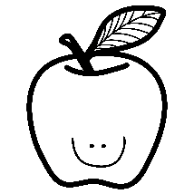
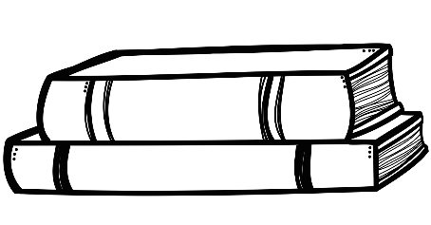
Review
Gr. 4
1. What is a rule?

2. What is a law?

3. What are rights?

4. What are two rights you have as a child?

5. How many rights do people have? List 2 rights all humans have.

6. What does the video: If the World Were a Village of 100 People… tell us about human and children rights?

7. What does the word Government mean? (See What is Government and Kinds of Government)

8. What are our three systems of government? (3 levels)

9. What does the municipal government look after? (Not responsibilities) Cities? Provinces? Countries?

10. What does the provincial government look after?

11. What does the federal government look after?

12. Who is the head of our municipal government? What is his job title and name?

13. Who is the head of our provincial government? What is his job title and name?

14. Who is the head of our federal government? What is his job title and name?

15. What are some responsibilities of our:
Municipal Government-

Provincial Government-

Federal Government-

16. Name the governmental buildings for:
Municipal-
Provincial-
Federal-

17. Is there a relationship between the three levels of government? Do they work together or separately?

18. What does MLA stand for?

19. What does MP stand for?

20. What are the major political parties in Canada? (Hint: there are 5) See Electing a Government.

21. Who represents the Queen in Canada? (See How a Bill Becomes a Law)

22. What is another name for a new law? (See How a Bill Becomes a Law)

23. How many readings does a bill have? (See How a Bill Becomes a Law)

24. Describe the voting process. (See How to Vote – 6 Easy Steps (the drawings you did)

25. What is it called when there is no government at all? Hint: A __ __ __ __ __ __

26. Why do you think people need some kind of government? Give at least three reasons. (See What is Government?)Short Answer.
________________________________________________________________________________________________________________________________________________________________________________________________________________________________________________________________________________________________________________________________________________________________________________________________________________________________

