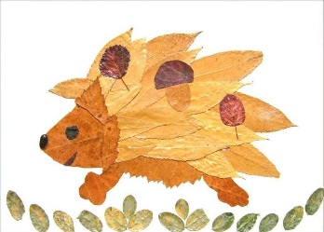
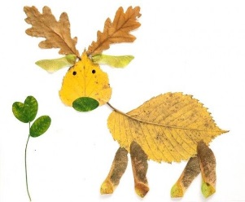
Leaf Art Project
For this art project, you will be creating an image or images of real life animals, people or objects using leaves you have collected. Every part of your image must be created using leaves and only leaves! No marker, no construction paper, only leaves! Be creative and pay special attention to detail.
Materials Needed:
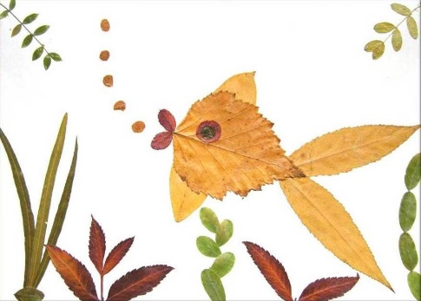
1. Wide variety of leaves in different shapes and sizes
2. 1 piece of cardstock paper
3. Liquid glue
4. Q-tips for gluing
Grading Criteria
- Evidence that careful thought was put into the completion of this art piece.
- The image created uses only leaves.
- The art piece is free of doodling, tears, smudges and glue marks. It is a clean finished piece.
- The completed art piece is detailed (patterns, eyes, toes, claws, tongue, and other creative leaf details).
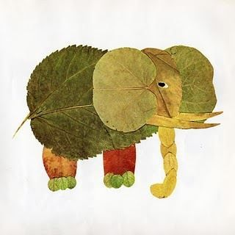
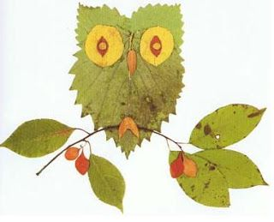
- The art piece resembles a real life object, person or animal.

