Name_______________
Patterns in Charts and Tables
Gr. 4 Review

Part 1: Identify the pattern on each Hundred Chart by first stating the pattern rule and then extending by the next 2 numbers in the pattern.
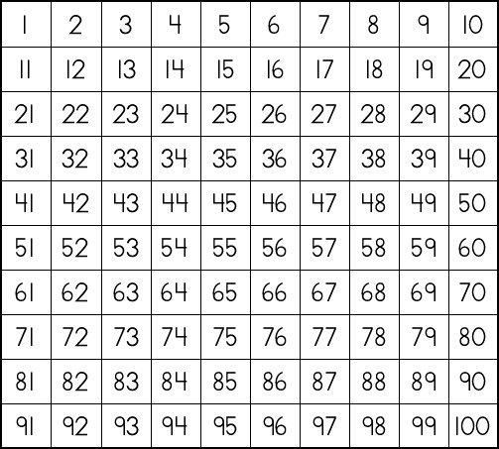
a)

Pattern Rule: __________________________________________________________________________________________________________
Extend: ______, ______

b)

Pattern Rule: __________________________________________________________________________________________________________
Extend: ______, ______
Part 2: Ms. Da Costa made a mistake in this Hundred Chart. Can you find it?
a)

Error: ______
Correction: _____

Part 3: Describe the pattern rule for each table below.

a)
Figure | Number
1 | 50
2 | 100
3 | 150
4 | 200

Pattern Rule: __________________________________________________________________________________________________________

b)
Figure | Number
1 | 33
2 | 44
3 | 55
4 | 66

Pattern Rule: __________________________________________________________________________________________________________

c)
Figure | Number
1 | 7
2 | 21
3 | 28
4 | 35

Pattern Rule: __________________________________________________________________________________________________________

Part 4: Extend the pattern in each table.
a)
Figure | Number
1 | 125
2 | 150
3 | 175
4

b)
Figure | Number
1 | 424
2 | 430
3 | 436
4

Part 5: Identify the missing numbers in each figure.
a)
Figure | Number
1 | 8
2
3 | 24
4 | 32

b)
Figure | Number
1
2 | 10
3
4 | 20

c)
Figure | Number
1 | 4
2
3 | 12
4 | 16

Part 6: There is one error in each table. Identify it and correct it.
a)
Figure | Number
1 | 20
2 | 23
3 | 29
4 | 29

Error: ______
Correction: ______
b)
Figure | Number
1 | 500
2 | 525
3 | 550
4 | 600

Error: ______
Correction: ______

c)
Figure | Number
1 | 88
2 | 77
3 | 65
4 | 55

Error: _______
Correction: ______

Part 7: Draw the pattern. Don’t forget to include the figures!
Figure | Number
1 | 2
2 | 5
3 | 8
4 | 11

Part 8: Extend Patterns in a Table to Solve a Problem
1.
Week | Height (inches)
1 | 2
2 | 4
3 | 8
4 | 16
5
6

Ms. Da Costa’s class planted seeds. As the plants began to grow, they started to noticed that the plants’ height was growing in a pattern!

a) What is the pattern rule? __________________________________________________________________________________________________________
b) How many inches tall will the plants be in the fifth week?________
c) How many inches tall will the plants be in the sixth week? ________
2. Owyn wants to throw his grade 3/4 class a pizza party! Wow! So nice of you Owyn! There are 27 students in the class. Each box of pizza contains 8 slices.
Box | Pizza Slices
1 | 8
2
3
4
5

a) How many boxes of pizza will Owyn need to order for each student to get one slice? ___________

b) How many slices of pizza would be in 5 boxes? __________

