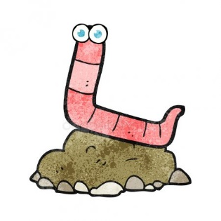
Soil Layers
Assignment
What to do: For this assignment, you will be illustrating the 5 layers of soil we learned about in class. This illustration will include a description of each layer as well as carefully thought out images.
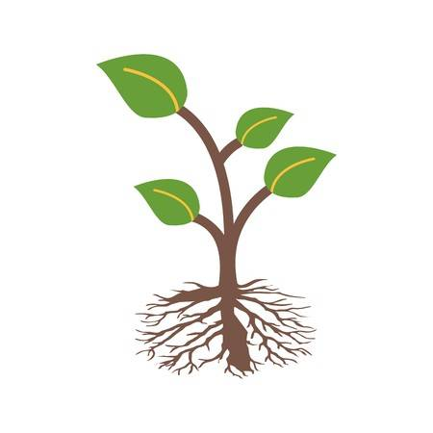
Criteria

1. Clearly label all 5 layers of soil.

2. Include a description of each layer.
(Colour, size, texture, what exists there, etc.).

3. Using pencil crayons, illustrate each layer. Include any images that may show what you find in this layer (colour, minerals, rocks, roots from plants, worms, ants, moles, etc).

4. The more detail, the better! Really impress me. Label your images if you think it would be helpful

Helpful Tips: Re-watch the video Layers of Soil from Youtube. Look through your duo-tang to find the descriptions of each layer.

