Name_______________
Graphing Review
Gr. 3
I can show understanding of data using tally marks, charts, bar graphs, pictographs and line plots by creating graphs and answering questions.

Tally Charts
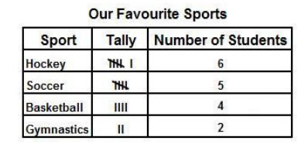
1. What sport received the MOST votes?
_____________________

2. What sport received the FEWEST votes?
_____________________
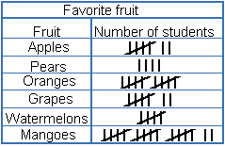
1. How many types of fruits were chosen to collect data for?
_____________________

2. Write down one piece of information you were able to gather from this chart.
__________________________________________________
Bar Graphs

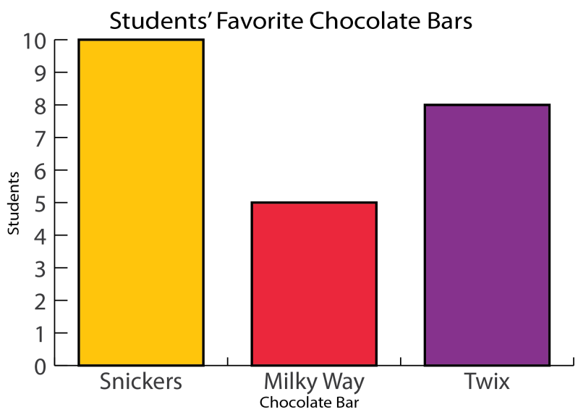
1. How many students voted for Twix?
___________________
2. How many votes did Twix and Snickers receive altogether?
___________________
3. How many more students voted for Snickers than Milky Way?
___________________

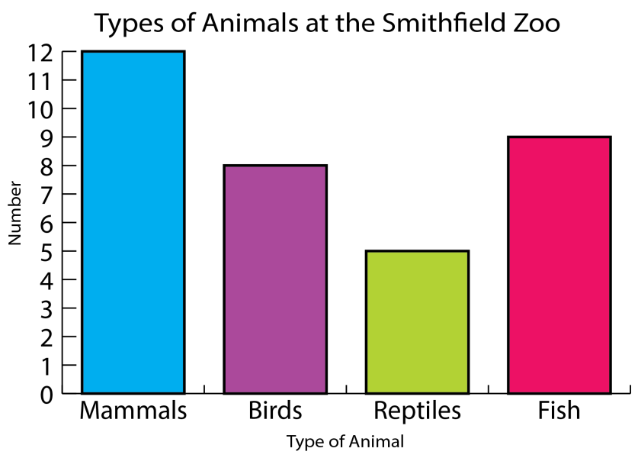
1. How many types of animals are there at
the Zoo?
_______________________
2. What kind of animal does the Zoo have the most of?
_______________________
3. Write down one other piece of information you know from this graph.
___________________________________________________

Pictographs
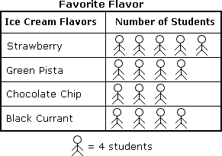
1.What is the title of this graph?
________________________
2.What type of graph is this?
________________________
3.What is the key?
________________________

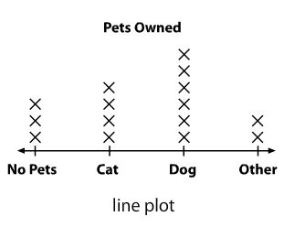
Line Plots

1. Which pet do most children own?
______________________

2. Why does this line plot have “Other” on it? What does it mean?
____________________________________________________

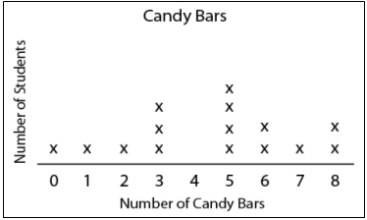
1. What is the title of this line plot?
________________________

2. How many students voted altogether?
________________________

3. How many students ate 4 candy bars?
________________________

4. What is the label of the horizontal axis?
_________________________

Directions: Create a bar graph of your very own. Include a title and a scale (numbers on the side) and label both the vertical and horizontal axis. Use a tally chart to help you gather your data.
Tally Chart (begin here)

_______________________________
(Title)

Name_______________
Graphing Review
Gr. 4
I can show an understanding of tally charts, bar graphs and pictographs by comparing, answering questions and creating graphs.

Tally Charts
1. What sport received the MOST votes?
_____________________
2. How many students voted altogether?
_____________________
3. Create a bar graph to show the exact same data. (Don’t forget the title, scale and to label both axis)

1. How many types of fruits were chosen to collect data for in all?
_____________________

2. Write down two pieces of information you were able to gather from this chart.
__________________________________________________
__________________________________________________

Bar Graphs

1. How many students voted for Twix?
___________________
2. How many more students voted for Snickers than Milky Way?
___________________
3. Which chocolate bar is the least favourite?
___________________

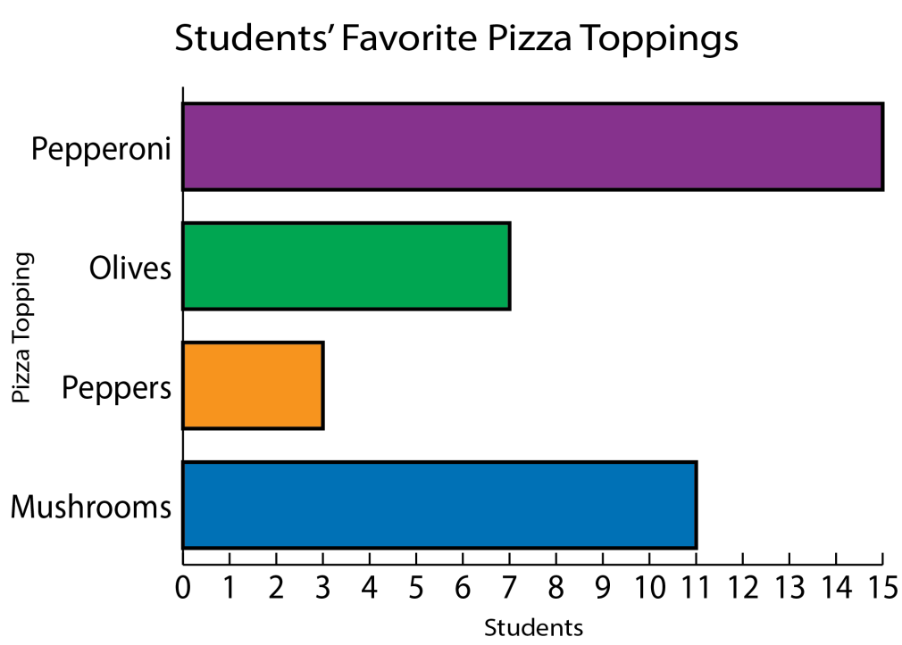

1. How many types of pizza toppings were voted for altogether?
______________________

2. What are the titles of both
axes?
______________________
______________________

3. Create a tally chart that displays this exact same information.

Pictographs
1.What is the title of this graph?
________________________
2.What type of graph is this?
________________________
3.What is the key?
________________________

4. Create a bar graph to show this exact same information.

Directions: Create a bar graph of your very own. Include a title, scale and both axes. Use a tally chart first.

_______________________________
(Title)

