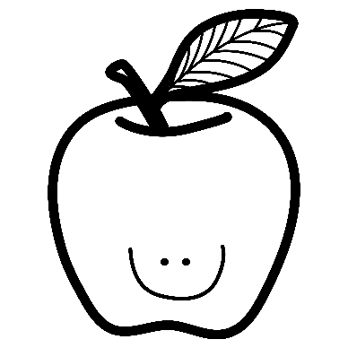
Grade 3/4 Spelling Program

In our class, students spelling tests are created based on the words they are currently reading and writing with in class each and every day. Basically, when students receive a new spelling list, they receive words that they have already been familiarized with or words that they will soon be learning about. This type of spelling program helps to expand students’ vocabulary and teaches them how to correctly spell the words we are presently applying to our classroom work. Students will receive a new list of Spelling Words every Day 5. Their quiz will then be the following Day 5 (1 week to practice). There will be the odd time that re-scheduling will have to occur due to field trips, assemblies, PD Day’s, etc. Furthermore, students will have time during Daily 5 to practice their Spelling words multiple times throughout the week, however, at home practice increases success. Lastly, at times, you may notice that your child receives fewer/more words or more simple/challenging words. Throughout the year, I will swap students around based on their successes or challenges with spelling (10 words vs 15 words). Spelling Quiz scores are not submitted to Grade Book and they do not receive a Progress Report grade. If you have any questions, please feel free to e-mail me!

Ms. Da Costa
Spelling List #1
Looking Not Looking
1. igneous _________________ ________________
2. sedimentary _________________ ________________
3. metamorphic _________________ ________________
4. erosion _________________ ________________
5. sediment _________________ ________________
6. magma _________________ ________________
7. lava _________________ ________________
8. weathering _________________ ________________
9. municipal _________________ ________________
10. provincial _________________ ________________
11. federal _________________ ________________
12. government _________________ ________________
13. responsibility _________________ ________________
14. courage _________________ ________________
15. courageous _________________ ________________

Your first spelling quiz will be on Thursday, October. 24th

