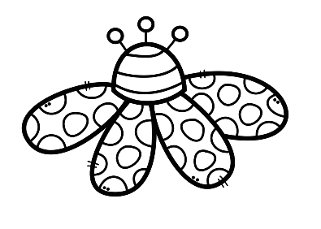
The Seven Levels of Life Assignment
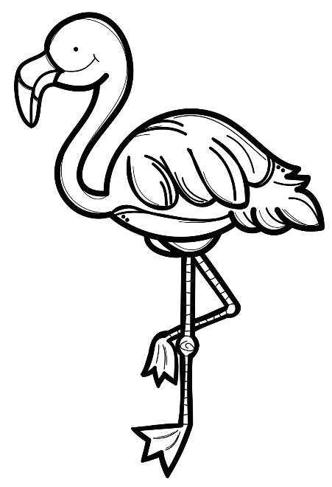
For this assignment, you will be depicting the Seven Levels of Life to show the interdependence of plants and animals. Please use the paper provided and record the name of each level as well as 5 labelled images for each. Here is what I am looking for:
Criteria Check List:
- All Seven Levels neatly labeled with correct spelling and capitalization
- 5 images specific to each level
- All images are labelled with neat printing and correct spelling

Want to earn a 4 ? (Yes you do!)
- Use Word Art or Fancy writing to label each level
- Provide more than 5 labelled images
- Provide specific names of plants and animals. For example, rather than plant write cactus, rather than bird write flamingo, rather than frog write Poison Arrow Frog.
- Colour the background of the levels

Before you submit your finished product, go through the criteria and make sure you have included everything.

